This n That

An e-mail newsletter from Agapé Athletics Club

Editor: Marieta Bortoli 082 466 7031 29 January 2018 www.agape.org.za

E-mail: marietabortoli@gmail.com

NB

- Next league race –
- Agapé race (Jacaranda City Challenge) – 13 October Members to assist. PLEASE DIARIZE !!!!!!

Editorial

Our new running vests arrived. You have three years to change to the new vest. This coming Saturday
3 February, the vests will be sold at our gazebo at the McCarthy race. There after you can purchase it at
Run-a-Way Sport.

From this Saturday you must wear your 2018 license number.

We have co-opted a new member to the EXCO. Welcome Suzette. Her contact details are listed under EXCO members.

Notice Board Additions

◊ Spar Lantern Night Race
◊

Attachments

□ 2018 Agape registration form
□ 2018 ASA registration form
□

Birthday Greetings

May God look down and bless you now when your birthday’s here and keep you in His loving care each day throughout the year, and may He grant you happiness in everything you do – today, tomorrow, always, every day your whole life through!

Robert Stutterheim 29 January | Martie Boesemberg 31 January
Natalie Marais-Werner 01 February | Walter Meyer 05 February
Louw Van Zyl 06 February | Koos Hofmeyr 07 February
Mia Reinecke 07 February | Christian Cronje 15 February
Marcel Hattingh 18 February | Cornel Maartens 18 February
Stefan Bothma 19 February | Rieme Engelbrecht 22 February
Laetitia van Wyk 22 February | Kay Liebenberg 23 February
Hendrik van Schalkwyk 23 February | Jaco Barkhuizen 28 February
Alberta Wamelink 29 February

Personalia

Welcome new and former members

William Kiewitt Melanie Kruger

Congratulations

Congratulations to the following members:

Thank you’s

In the mailbox

Comrades 2018
Ek sal dit baie waardeer indien jy vir my in julle nuusbrief kan adverteer dat ek ‘n “substitution” soek vir Comrades.
My detail is as volg: Tina Fourie, cell nr 082 492 1377, e-pos adres: tina@hsi.co.za.
Baie dankie, ek waardeer dit opreg.
==
Ek (Marius vd Westhuizen) is ook opsoek na n Comrades Inskrywing, ek was aan die slaap gevang en het die inskrywings gemis.
Indien iemand kan help kontak asseblief vir Marius – 082 576 6755 of marius@tsconline.co.za
==
Loskop
Loskop 2018 entries is now open. Below will be link for entries:
http://www.loskopmarathon.co.za/

General
Clothing available:
Buffs @ R100
Ladies skirts @ R200
Second skins @ R220
Age tags @ R30

Please contact Marietjie if you wish to purchase some of the items:
Cell: 072 541 7268 E-mail: ventermarix9@gmail.com
The items will also be available at races, please visit our gazebo

2018 Registrations:
Fees for 2018
1st member R350
2nd member/pensioner/student R300
Junior – under 19 R 90 (ID document to be submitted with application form)
Social member R100

Please complete the attached two forms and return to Hennie Venter at henniev@seng.co.za or
join@agape.org.za. Forms can also be handed in at races where Hennie will be available

Race reports/Upcoming race information

Wonderpark/Akasia, league race over 5km, 10km, 21,1km and 42,2km – de Wet de Beer
Why a race report, I ask myself? Not a difficult question to answer. To make all club members that couldn’t be there, jealous that they missed out off course!!! So, what was different and what stayed the same? Is it worth running races, for ‘MY AGAPÉ’

The club gazebo was there to serve us, as per usual. Hennie registered more athletes for the club, as per usual this time of year. Coffee and tea (plus muffins were served), as per usual. My tog bag was kept safe (as per usual). We got together for a prayer before the race (as per usual). These things didn’t change. But, we feel welcome here and that makes the ‘usual’ things great. Fellow runners are brothers/sisters and share experiences – this makes getting together even greater.

This was my first 21km in 9 months, but the race definitely didn’t feel that far as I was running with an Agapé friend, who accompanied me all the way – before continuing with his own 42km race. “We” made the goal set before the race even though my Garmin said we ran 160m too long on the 21,1km. The race is held in the “Akasia Flats” (not really its name), a residential neighbourhood, with no ‘proper’ hills: only “slow poisons”. We had no ‘major’ roads to cross – and I didn’t see any infuriated motorists. The 21,1km was a single lap race and the 42,2km a double lapper.

What made the huddle at the gazebo after the race “more personal” was the rain that came down in bucket loads as the race was progressing. Our hearts go out to all Capetonians (and surrounds) during this time of drought.

I asked my friend Chris, visiting from Delhi, India (working there for the last 21 years) if he exercises. His answer surprised me. He answered that during a specific season in Delhi they didn’t see the sun for more than 2 weeks because of the ‘smog’. I looked it up on the internet and found a ‘race photo’ of the Delhi 21.1km challenge that took place in 2017.
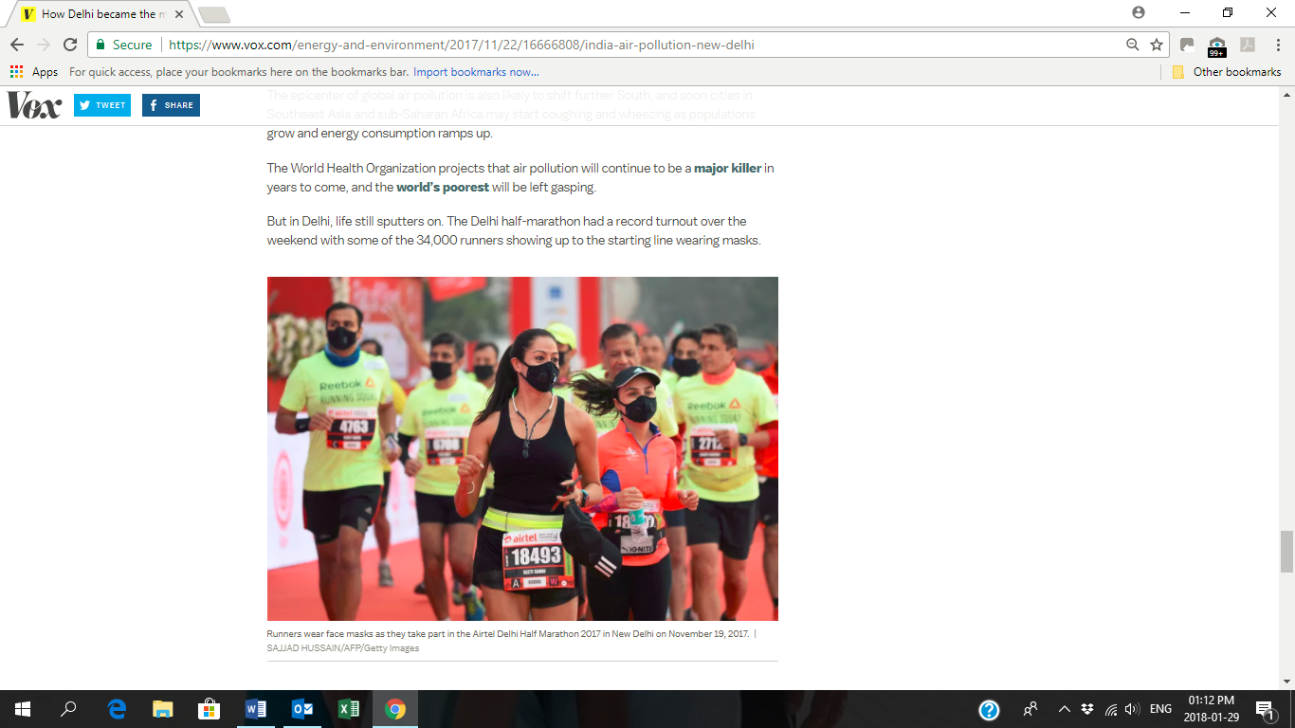
All of the above makes me truly grateful that I am part of our club and that I can run with all you beautiful people, week in and week out (without having to wear masks!!!)

Race Results
George Claassen (AGN) 10km race - 2018-01-20
Position | Initials | Surname | Sex | Age | Finish Time
30 | J | Pokwane | M | 46 | 00:40:52
184 | D | De Beer | M | 46 | 00:53:58
204 | E | Dirkse Van Schalkwyk | F | 42 | 00:54:31
221 | M | Kruger | M | 24 | 00:54:55
228 | G | Smit | M | 66 | 00:55:16
266 | L | Fourie | M | 72 | 00:56:56
379 | M | Reinecke | M | 43 | 01:00:07
723 | C | Maartens | F | 31 | 01:06:54
724 | P | Coetzee | M | 67 | 01:06:55
883 | R | Hughes | F | 69 | 01:08:56
1081 | O | Kruger | F | 48 | 01:12:46
1091 | C | Mouton | F | 61 | 01:12:53
1231 | M | Scheepers | M | 54 | 01:15:26
1233 | R | Sher | M | 74 | 01:15:27
1256 | E | Du Toit | F | 66 | 01:15:40
1307 | A | Potgieter | F | 46 | 01:16:43
1349 | B | Siconoi |  |  | 01:17:34
1350 | K | Van Der Merwe |  |  | 01:17:35
1560 | C | Scheepers | F | 52 | 01:23:13
1675 | L | Clarke |  | 74 | 01:26:11
George Claassen (AGN) 21km race - 2018-01-20
Position | Initials | Surname | Sex | Age | Finish Time
192 | K | Imrie | M | 46 | 01:45:47
217 | A | Dicks | F | 39 | 01:47:24
368 | C | De Kiewit | M | 58 | 01:54:48
762 | M | Brummelkamp | M | 38 | 02:07:56
789 | E | Wolhuter | F | 37 | 02:08:39
799 | M | Atkins | F | 48 | 02:08:59
800 | M | Malan | F | 59 | 02:08:59
971 | M | Van Der Westhuizen |  | 55 | 02:13:59
1004 | W | Weder | M | 69 | 02:15:10
1246 | M | Boesemberg | F | 60 | 02:21:50
1259 | A | Lenoge | F | 44 | 02:22:09
1265 | T | Lenoge | M | 48 | 02:22:11
1325 | S | Brink | M | 47 | 02:23:51
1490 | R | Le Roux | M | 63 | 02:30:14
1575 | J | Hofmeyer | M | 65 | 02:34:08
1593 | A | De Reti | M | 68 | 02:35:29

George Claassen Walk (AGN) 10km race - 2018-01-20
Position | Initials | Surname | Sex | Age | Finish Time
181 | E | Loubser | M | 61 | 01:56:23
191 | M | Stander |  |  | 02:16:52
Akasia Wonderpark (AGN) 10km race - 2018-01-27
Position | Initials | Surname | Sex | Age | Finish Time
242 | J | Kruger | M | 24 | 00:54:15
256 | L | Nel | M | 50 | 00:54:56
299 | K | Nurden | M | 83 | 00:56:11
312 | C | Burger | M | 53 | 00:56:36
602 | A | Kluge | M | 70 | 01:03:46
651 | R | Stutterheim | M | 69 | 01:04:36
657 | C | Maartens | F | 31 | 01:04:46
703 | K | Kennedy | F | 37 | 01:06:11
753 | P | Coetzee | M | 66 | 01:07:37
821 | J | Ferreira-prevost | F | 44 | 01:08:52
838 | A | Du Plessis | F | 62 | 01:09:10
844 | A | Smith | F | 51 | 01:09:13
929 | O | Kruger | F | 48 | 01:10:49
1418 | F | Lisse | M | 73 | 01:20:32
2081 | S | Bothma | M | 43 | 01:33:17
Akasia Wonderpark (AGN) 42km race - 2018-01-27
Position | Initials | Surname | Sex | Age | Finish Time
51 | J | Pokwane | M | 46 | 03:03:48
646 | J | Kruger | M | 44 | 04:14:10
1479 | L | Groenewald | F | 48 | 04:59:45
Akasia Wonderpark Walk (AGN) 10km race - 2018-01-27
Position | Initials | Surname | Sex | Age | Finish Time
30 | J | Barkhuizen | M | 47 | 01:15:03

Training/Health snippets

Shoes:
Contrary to popular belief, it is not necessarily true that the lighter the shoe, the more economical will be the running. This is because the effectiveness of running shoes is a function of shoe weight and design, not just one factor or the other. The situation is further complicated by individual running style. Stride length and rate play a role in running economy, as does the way each runner’s feet strike the ground. Some runners use less energy with one type of foot plant, while others do best with a different technique. It is a case of individual makeup interacting with various combinations of stride rate, stride length, shoe type, and foot strike, in addition to the surface over which you are running. There is no right way that suits everyone. Just as different coaches and runners relate differently, so do different techniques suit various runners in different ways.

The materials used in various parts of shoe midsoles and the composition and design of outsoles also affect running economy. Plus, the surface over which the athlete is running becomes a factor. A very light shoe with poor cushioning may be a relatively “costly” shoe, especially for a rear-foot runner (a runner whose feet first strike the ground with their heels, or rear of the foot). This would be particularly true on a hard surface, such as a road. (Source: Daniels’ Running Formula)

Your thought for the week

By forgiving, we destroy the root of bitterness and the plant of anger dies!

Your smile for the week
It was mealtime during a flight on a British Airways plane:
'Would you like dinner?' the flight attendant asked the man seated in the front row.
'What are my choices?' the man asked.
'Yes or no,' she replied.
===
A lady was picking through the frozen turkeys at a Woolworth's store but she couldn't find one big enough for her family.
She asked a passing assistant, 'Do these turkeys get any bigger?'
The assistant replied, ' I'm afraid not, they're dead.'
===
The policeman got out of his car and approached the boy racer he stopped for speeding.
'I've been waiting for you all day,' the policeman said.
The kid replied, 'Yes, well I got here as fast as I could.'
===
A semi-trailer driver was driving along on a country road. A sign came up that read ' Low Bridge Ahead.'
Before he realised it, the bridge was directly ahead, and he got stuck under it.
Cars are backed up for miles. Finally, a police car comes up.
The policeman got out of his car, walked to the lorry's cab and said to the driver, 'Got stuck, eh?'
The lorry driver said, 'No, I was delivering this bridge and ran out of petrol!'

Something to ponder over / something spiritual

Now faith is the substance of things hoped for; the evidence of things not seen (Hebrews 11:1).
Have you noticed sometimes as you sit listening to God’s Word, the whole world suddenly seems small? All the challenges you may have been facing suddenly seem like nothing at that time! The reason is simple. At such a time, the Word of God is getting into your spirit and provoking a response from your inner man. That response is faith. Therefore the Bible says “… Faith cometh by hearing, and hearing by the word of God” (Romans 10:17).
Every time you hear God’s Word your spirit becomes energized, and faith comes to you. Faith is an attribute of the human spirit; it doesn’t operate in the realm of the physical senses; it was imparted to your spirit when you were born again (Romans 12:3). Thus, every time you hear the Word of God, it goes through your mind into your spirit, for it is designed for your spirit. That Word becomes more real in your spirit than the physical things that your senses perceive.
So, if the Bible says that faith is the evidence of the things we don’t see or perceive with our senses, as in the opening scripture, then faith is the evidence of what the Word says! Faith accepts and exalts what the Word says above the natural circumstances of life. Therefore, faith is that response that your spirit has to the Word of God.
That is why it’s vital for you to regularly study and meditate on the Word. There’s a spiritual reaction that is ignited between your spirit and the Word of God that gives you dominion over the circumstances of life! When that reaction takes place, faith rises in you like a giant and you have the assurance that you’re who God says you are, you have what He says you have, and can do what He says you can do! The challenges of this world will fade away as you find yourself relating with the realities of the Kingdom.
Confession
My spirit is attuned to the Word of God. Every time I receive the Word, my faith increases and produces greater results, and my spirit gain the ascendancy over the situations and circumstances of life. I can never be defeated because my faith is the victory that overcomes the world. Hallelujah.

Cancelled Races

Correctional Services Nite Race scheduled for 7 February

Notice Board

Useful Links:
www.raceresults.co.za/flyers - for the latest race pamphlets
www.agn.co.za/#League for the latest league logs and the league points you earned
http://www.agn.co.za/Docs/2018/Walking/AGN%20road%20walking%20stds%20ref%20685.pdf
AGN 2017 RW qualifying standards and selection criteria
www.runawaysport.co.za Run-A-Way Sport’s web site
www.verticalhorison.co.za Trail Running www.trailseries.co.za Trail Running
http://www.mastersathletics.net/Age-Graded-Calculator.2595.0.html Age Graded Calculator
http://www.sportsinjuryclinic.net/symptom-checker By clicking where it hurts then ticking which symptoms most apply to you we can give you an indication of what injuries may apply.

Saturday 3 February Bidvest McCarthy Toyota Race 21.1/10/5 km
Race Organisers: Magnolia Road Runners
Venue: Rietondale Park, North Street, Rietondale
GPS: S 25 43.980 E 28.13.239

 | 21.1 km | 10 km | 5 km
Entry fees until 28 January | R 120 | R 80 | R 50
Entry fees 2 & 3 February | Closed | R 100 | R 50
Entry fee 60+ | R 60 | R 50 | R 40
Entry fee 80+ | Free
Start Time | 06:00 | 06:20 | 06:25
Cut-off | 03:00

Free t-shirt to the 1st 2000 pre-entries

No Pets

No wheelchair athletes allowed

Pre-entries at: Bidvest McCarthy: Arcadia, Hatfield, Gezina, Lynnwood, Sinoville, Centurion; Run-away Sport; Sweatshop Southdowns, Dunkeld West

www.entrytime.com

Saturday 10 February Bronkhorstspruit 32/10/4 km
Race Organisers: Bronkhorstspruit Athletics Club
Venue: Hoërskool Erasmus, Cathy Street, Bronkhorstspruit

 | 32 km | 10 km | 4 km
Entry fee | R 150 | R 80 | R 20
Entry fee 60+ | Free
Start Time | 06:00 | 06:15 | 06:30
Cut-off | 04:30

1st 200 pre-entries receive a free t-shirt

No Pets

No wheelchair athletes allowed

Pre-entries at: Run-away Sport

www.enteronline.co.za

Wednesday 14 February Spar Lantern Night Race 10 / 5 km
Race Organisers: Irene Athletics Club
Venue: Irene ARC Campus, Centurion
GPS: S 25 89’71” E 28 19’ 87”
New venue 600m from Nellmapius Entrance

 | 10 km | 5 km
Entry fee | R 100 | R 60
Entry fee 60+ | 50% of entry
Entry fee 80+ | Free (temporary license on 10km still required)
Start Time | 19:00
Cut-off | 02:30

Entrance & no exit Main Road – close at 18:50
Entrance opposite Denel gate
Parking also available at Denel

The route is not suitable for wheelchairs

No pets

Wear headlamps or other lights please

Pre-entries at: Run-away Sport; Sweatshop Dunkeld, Southdowns, Bedfordview; Centurion Spar; Hennops Park Spar; Monument Superspar; Lyttelton Superspar; Queenswood SUperspar

www.sa-active.com / www.enteronline.co.za

League Race
Saturday 17 February Bestmed Tuks Race 42.2/21.1/10/5/1 km
Race Organisers: Tuks Athletics
Venue: UP Sports Campus, Burnett Street, Hatfield
GPS: S 25 44’58” E 28 14’47”

 | 42.1 km | 21.1 km | 10 km | 5km | 1 km
Entry fee | R 150 | R 100 | R 80 | R 50 | R 30
Entry fee 60 - 79 | R 80 | R 50 | R 40
Entry fee 80+ / blind athletes | Free
Start Time | 05:30 | 06:00 | 06:30  Wheelchair  06:20 | 06:40 | 08:00
Cut-off time | 05:30 | 03:00
42.2km race is a pre-entry race only and limited to 4000 runners

1st 2 500 pre-entries receive a free t-shirt for 10/21.1 & 42.2km

No Pets

Wheelchair athletes allowed on the 10km

Pre-entries at: Run-away Sport; Sweatshop Dunkeld, Fourways, Centurion

www.entrytime.com

Sunday 25 February The Deloitte Challenge 42.2/21.1/10 km (Pretoria Marathon)
Race Organisers: Phobians Athletics Club
Venue: Pretoria High School Old Boys Club, Hofmeyr Park, Queens Crescent, Lynnwood

 | 42.2 km | 21.1 km | 10 km
Entry fee | R 190 | R 130 | R 80
Start Time | 06:00 |  | 06:15
Cut-off | 05:30

42.2/21.1km entries open until 24 February – no race day entries

1st 5 000 pre-entries receive a free t-shirt

No Pets

Wheelchair athletes allowed

Pre-entries at: Run-away Sport; Sweatshop Southdowns, Dunkeld, Bedfordview

www.entrytime.com

Saturday 3 March Medihelp Sunrise Monster 32/10/5 km
Race Organisers: Harlequin Harriers
Venue: Harlequin Club, Totius Road, Groenkloof
GPS: S 25 40.122 E 28 13.031

 | 32 km | 10 km | 5 km
Entry fee | R 110 | R 80 | R 40
Entry fee 60+ | R 60 | R 40 | R 30
Race day entry (excluding 60+) | R 130 | R 90 | R 50
Race day & race eve entries (70+ / 80+) | Free
Start Time | 06:03 | 06:30 | 06:45
Cut-off | 04:30 | 02:00
T-shirts to all finishers, while stocks last, sizes are not guaranteed

No Pets

Wheelchair athletes allowed

Pre-entries at: Run-away Sport; Sweatshop Southdowns; Natuaral Runner Centurion

www.entrytime.co.za

2018 AGN LEAGUE FIXTURE LIST
EVENT | DISTANCE | DATE | LEAGUE
 |  |  | RR | RW
Bestmed Tuks | 21.1/10 km | 17/02 | X | X
Denel Road Race | 21.1/10 km | 24/03 | X | X
Morula Half Marathon | 21.1/10 km | 21/04 | X | X
Race of Hope | 21.1/10 km | 19/05 | X | X
Riana van Niekerk Run/Walk for Bibles | 21.1/10 km | 30/06 | X | X
Ice Breaker | 21.1/10 km | 07/07 | X | X
SMU Half Marathon | 21.1/10 km | 28/08 | X | X
Clover Irene Spring Race | 21.1/10 km | 29/09 | X | X
CSIR Road Race | 21.1/10 km | 21/10 | X | X
Tom Jenkins | 21.1/10 km | 17/11 | X | X

Masters Athletics Fixture list

Local meetings
23/24 March 2018 GNMA (throws & Track & Field) Pilditch/Tuks?
7 April 2018 CGMA Herman Immelman, Germiston
6/7 April 2018 WP Groenpunt, Cape Town ?
20 October 2018 SWD Oudtshoorn
10 November 2018 Free State Bloemfontein
KZN still to be announced KZN Durban

SA Masters Championships
26/27/28 April 2018 Bloemfontein

International Championships
24-30 March 2019 WMA Indoor Torun, Poland
20/7/2020 – 1/8/2020 World Masters athletics Champs Toronto, Canada

Time Trials:

Centurion -
Lewende Woord Centurion on Wednesdays at 17:30
Contact Marinda 654 5800 (h) / 082 720 9017

Rietondale –
North Street, Rietondale (Rietondale Park in the street before the Crawford Stadium) Thursdays 17:30
Contact Dorothy Benadie 082 704 2300 dorothy.benadie@gmail.com or
Hennie Venter 083 702 4472

Zita Park - Tuesdays at 17:30
Zita Street, Zita Park, Garsfontein
Contact Hennie Venter – 083 702 4472 Marietjie Venter – 072 541 7268

Gazebo Enquiries

Hennie Venter – 082 676 6792 Marietjie Venter – 072 541 7268

Intercessor:



Fred Harding 076 777 7786

Agapé Executive 2017/2018

Name | Position | Telephone number | E-mail address
Marieta Bortoli | Chairperson & editor | 012 331 2089  082 466 7031 | marietabortoli@gmail.com
Hennie Venter | Registrar & club captain & Vice-chairperson | 082 676 6792 | henniev@seng.co.za  join@agape.org.za
Marilett Jenkins | Secretary | 082 837 2142 | marilett.jenkins@mervitzmalan.co.za
André Breytenbach | Treasurer | 083 566 1090 | andreb@geoscience.org.za
De Wet de Beer | PRO | 082 373 2987 | dewet@styletechnique.co.za
Kobus Stander | Race organiser | 082 688 6697 | CLK1560PHARM@clicks.co.za
Fred Harding | Intercessor | 076 777 7786 | fredharding@telkomsa.net
Marietjie Venter | Clothing co-ordinator | 072 541 7268 | Ventermarix9@gmail.com
Suzette van Staden | General activities | 083 290 6280 | suzettevs971220@gmail.com
Gustav Brink | Statistician | 083 417 8431 | gustav.brink@gmail.com

Photo corner

Agapé Executive

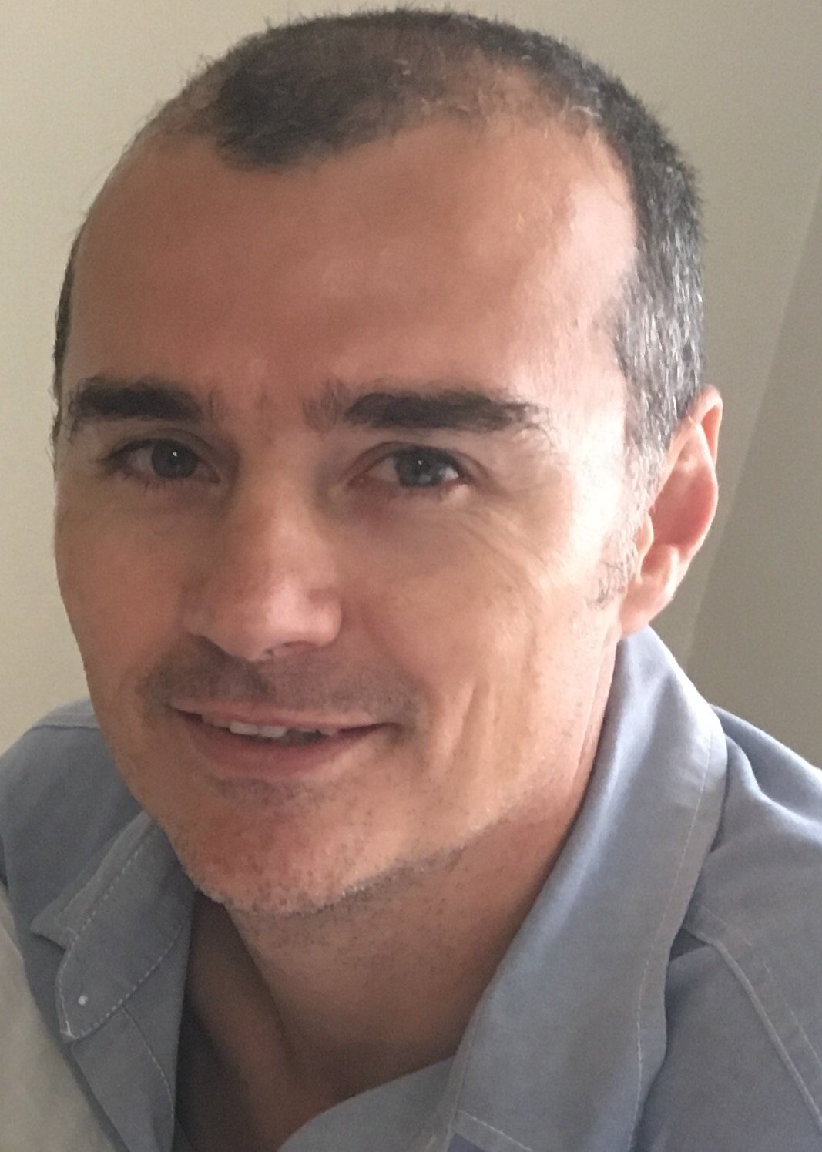
Marieta Bortoli Marilett Jenkins De Wet de Beer

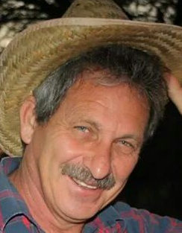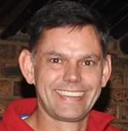
Hennie Venter André Breytenbach Kobus Stander

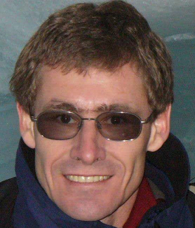
Marix Venter Fred Harding Suzette van Staden Gustav Brink (Ex-officio)

